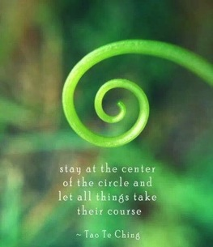 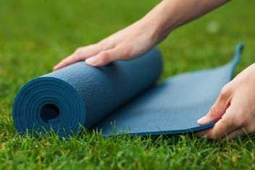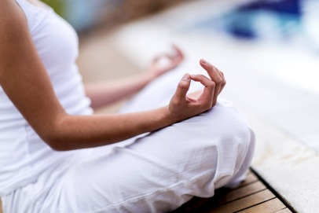

Page 4 – June special offers

Editorial

Welcome to our June edition with the theme of Mindfulness. There is an ever growing body of evidence that is starting to show that mindfulness practice (eg meditation and other mindful activities eg pilate and yoga) can significantly impact on our general health and wellbeing – to the point that we can change the way our DNA behaves and thus reduce the risk of developing chronic disease. By making a simple change to your lifestyle you can improve your quality of life and even perhaps lengthen it!

There are many different ways to introduce mindfulness to your general day to day life and everyone has a difference preference. The key is to experiment with a few different styles of meditation ( guided or non guided, still or moving, activity based or relaxation based). Once you find your preference you need to be regular in your practice to feel the benefits – which can include improved relationships, mental clarity and improved sense of wellbeing. Do yourself a favour and get meditating – it’s one of the best things you can do for yourself and those close to you .

We have a couple of great special offers this month for our regular pilates clients and a massage promotion to launch endermosport at Revive x

*Have a great month - Jules*

* University of New Mexico researchers found that participation in a Mindfulness-Based Stress Reduction course decreased anxiety and binge eating.
* Office workers who practiced MBSR for twenty minutes a day reported an average 11% reduction in perceived stress.
* Eight weeks of MBSR resulted in an improvement in the immune profiles of people with breast or prostate cancer, which corresponded with decreased depressive symptoms.
* A prison offering Vipassana meditation training for inmates found that those who completed the course showed lower levels of drug use, greater optimism, and better self-control, which could reduce recidivism.
* Fifth-grade girls who did a ten-week program of yoga and other mindfulness practices were more satisfied with their bodies and less preoccupied with weight.
* A mix of cancer patients who tried MBSR showed significant improvement in mood and reduced stress. These results were maintained at a checkup six months later.
* The likelihood of recurrence for patients who had experienced three or more bouts of depression was reduced by half through Mindfulness-Based Cognitive Therapy, an offshoot of MBSR.
* After fifteen weeks of practicing MBSR, counseling students reported improved physical and emotional well-being, and a positive effect on their counseling skills and therapeutic relationships.
* *There appears to be a growing body of evidence to show that we cannot afford to not practice this form of meditation for the sake of our general health and wellbeing.*

THE SCIENCE BEHIND MINDFULNESS

The practice of intentional, nonjudgmental awareness of moment-to-moment experience has been practiced since ancient times in both East and West. Wisdom traditions have for thousands of years recommended mindful practice in a variety of forms to cultivate well-being in an individual’s life. Now science is confirming these benefits.

Jon Kabat-Zinn, a microbiology Ph.D. then teaching at the University of Massachusetts Medical Center, was inspired in the late 1970s to apply the basic principles of mindfulness meditation to patients in a medical setting. His work developing the Mindfulness based stress reduction (MBSR) program proved effective in helping alleviate the suffering of chronic and previously debilitating medical conditions such as chronic pain.

MBSR is the practice of carefully focusing attention and cultivating an awareness of awareness and paying attention to intention.

Studies show that the ways we intentionally shape our internal focus of attention in mindfulness practice induces a state of brain activation during the practice. With repetition, an intentionally created state can become an enduring trait of the individual as reflected in long-term changes in brain function and structure. This is a fundamental property of neuroplasticity—how the brain changes in response to experience. Here, the experience is the focus of attention in a particular manner.

There has been some recent scientific findings on the benefits of practicing mindfulness :

Page 2 – the how and why of meditation…….

Page 3 – introducing our new admin team

June Newsletter 2016 – MINDFULNESS

.

Mindfulness practice may change the way our DNA behaves

Meditation is good for you. We don't need to tell you that. The [chorus of voices](http://www.fastcompany.com/3009764/dialed/the-big-chill-out-how-meditation-can-help-with-everything) extolling the [virtues of mindfulness](http://www.fastcompany.com/3036363/how-to-be-a-success-at-everything/meditation-techniques-for-people-who-hate-meditation) is never-ending: It decreases stress. It helps you focus. It can even [rewire your mental circuitry](http://www.mindfulmuscle.com/meditation-training-sculpts-brain/). But it's not just your synapses that see the benefits: As it turns out, meditating can physically change your DNA.

In [a recent study](http://www.scientificamerican.com/article/changing-our-dna-through-mind-control/), the use of mindfulness meditation was shown to have an impact on certain types of DNA in breast cancer patients. Specifically, the length of telomeres—these are the tiny protective caps on the end of chromosomes—was physically altered as the result of this type of meditation.

The study, which was published in the Canadian journal Cancer, showed that the length of telomeres was preserved by meditation. Why does that matter? Shorter telomeres aren't explicitly problematic, but they do tend to correlate with things like cancer, heart disease, and diabetes. So, if we can manage to keep these microscopic structures from whittling down in size, our health is better off.

This isn't the first time that Buddhist-style mindfulness meditation has been linked to the molecular goings-on of our biological makeup. A December 2013 [study from the University of Wisconson-Madison](http://www.news.wisc.edu/22370) demonstrated that the DNA of subjects who meditated "showed a range of genetic and molecular differences, including altered levels of gene-regulating machinery and reduced levels of pro-inflammatory genes, which in turn correlated with faster physical recovery from a stressful situation."

The telomere length correlation goes back to 2008, when a study found that stress management, aerobic exercise, and a vegan diet had an impact on telomere length in prostate cancer patients.

So while the evidence continues to grow, why not take the bull by the horns and get meditating – it can only do you good!

MEDITATION – HOW DO I START?

Mindfulness meditation practice couldn’t be simpler: take a good seat, pay attention to the breath, and when your attention wanders, return. By following these simple steps, you can get to know yourself up close and personal.

Find a good spot , ideally where there isn’t too much clutter and you can find some quiet. Leave the lights on or sit in natural light. You can even sit outside if you like, but choose a place with little distraction.

At the outset, it helps to set an amount of time you’re going to “practice” for. Otherwise, you may obsess about deciding when to stop. If you’re just beginning, it can help to choose a short time, such as five or ten minutes. Eventually you can build up to twice as long, then maybe up to 45 minutes or an hour. Use a kitchen timer or the timer on your phone. Many people do a session in the morning and in the evening, or one or the other. If you feel your life is busy and you have little time, doing some is better than doing none. When you get a little space and time, you can do a bit more.

Sit comfortably in a chair or on some kind of cushion on the floor. It could be a blanket and a pillow. Sit in a chair with your feet on the floor, loosely cross-legged, in lotus posture or kneeling. Just make sure you are stable and erect. If the constraints of your body prevent you from sitting erect, find a position you can stay in for a while.

When your posture is established, feel your breath—or some say “follow” it—as it goes out and as it goes in. Inevitably, your attention will leave the breath and wander to other places. When you get around to noticing this—in a few seconds, a minute, five minutes—return your attention to the breath. Don’t bother judging yourself or obsessing over the content of the thoughts. Come back. You go away, you come back. That’s the practice. It’s often been said that it’s very simple, but it’s not necessarily easy. The work is to just keep doing it. Results will come with consistent practice (like with any skill acquisition).

APPS AND GUIDED MEDITATIONS

There are some great apps and guided meditations available online.

Headspace is one of our favourites – meet Andy the guy with the most relaxing voice ever ! Andy guides you through how to start meditation process for 10 mins a day for 10 days (for free).

These initlal 10 days give you a taste of this style of meditation and if you like it and want to continue your practice, you can subscribe to a complete range of guided meditations with lots of different themes like meditation for focus, weight loss, stress, organization etc. Find HEADSPACE IN THE APP STORE

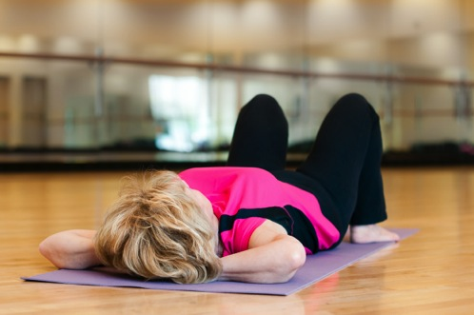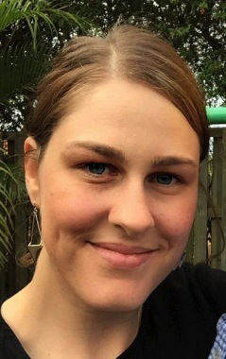

**What does mindfulness meditation have to do with pain?**

Practising mindfulness meditation can be helpful for people with persistent pain, with moderate effect in reducing pain intensity. Compared to normal medical care for pain, meditation also seems to improve other important aspects of life, such as depression, coping ability, quality of life, acceptance, sleep quality and physical functioning. When it comes to acute or short term pain, people report less distress and can tolerate more pain in the research laboratory when they have had meditation training, compared to people who do not meditate.

Overall, the current evidence suggests that mindfulness-based treatments are about as good as well-established psychological treatments for persistent pain, like Cognitive Behaviour Therapy (CBT). However, since the research on meditation is newer, it is not yet as strong and convincing as the research on CBT. There is still the need for more high quality studies to figure out which types of pain meditation helps most with, what doses of meditation work best, and what the essential ingredients are that make meditation helpful.

**Grace**

Receptionist

Grace comes to us with a background in dental and physio reception in Sydney. Grace will be fulltime on our admin team.

Jade

Part time reception

Jade is currently studying Exercise science and is also working at Goodlife on reception.

Vicky

Receptionist

Vicky comes to us from a background in Property reception and management. Vicky will be one of our full time admin team.

STAFF NEWS

We are excited to introduce you to our new admin team. We have had a number of new admin staff start with us recently and they have undergone some intense training to bring them up to speed on driving the reception desk and supporting our therapists and instructors. We welcome

Peggy

Senior administration (part time)

Peggy has extensive experience in office administration, bookkeeping and general organizing!



Client of the month:

Andrew L’estrange.

Andrew has been working with Melissa, Glen and Aggie since January this year and is a regular pilates client at the studio. Andrew started pilates to help with his lower back pain. Andrew has been very diligent with his Home exercises, pilates program and taken on board the education and advice he has been given.

Andrew is away with work a lot, and has to rely on his home exercises to maintain his core strength and flexibility. He is very happy with his progress and and we are so pleased to have helped him become painfree.

"Compliance is the key" and Andrew is the perfect example of this. Congratulations Andrew and enjoy your massage !

(Andrew wins a half hour massage at Revive)

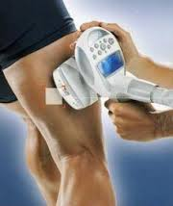

June Special offers

**REPEAT THE DEAL**   
(For existing equipment pilates clients)

This month we are offering our existing equipment pilates clients the opportunity to re-purchase the last pack they purchased on special at the same price!

(our large pilates packs will be on sale next month for those who wish to purchase a larger value pack for the first time)

**Endermosport Massage offer**

Purchase a pack of three massages this month and you will receive an extra half hour of therapy with ENDERMOSPORT. Endermosport is therapeutic massage that works the fascia deeper than manual massage using a mechanical device that lifts and rolls tissue.

(save $63)

3 pack massage plus endermosport offer

$249

Revive Ashgrove www.revivestudio.com.au

Level 1, 240 Waterworks Rd Ph: 3366 0500

**Nutrition - Speedy Sweet Potato Frittata (Serves 1)**

 Ingredients:

* 1 cup cooked leftover baked sweet potato, diced
* Few fresh rosemary leaves
* A little olive oil for frying
* 2 large eggs
* Baby kale and low fat feta cheese to serve

Method:

* Heat a little olive oil in a small non-stick fry pan over a medium heat and saute sweet potato with rosemary;
* Crack the eggs into a bowl and lightly whisk with a fork;
* Pour egg mix into pan and gently move around with a wooden spoon until almost cooked through;
* Place under pre-heated grill until eggs are set and lightly brown;
* Turn onto a plate and serve with some baby kale, and sprinkle with low fat fetta cheese.

Recipe: [Lifestar Nutrition and Exercise Physiology](http://camscyclecoaching.us6.list-manage.com/track/click?u=ce3590ffc4d6e0be602855cec&id=86860124c6&e=c110016eaf).